U NIT 1 POLITICAL ORGANIZATION OF THE SOCIETIES.

INTRODUCTION:

We are going to learn about:

- The structure of a state
- International relations and globalisation
- The territorial relations and globalisation
- The territorial organisation of Spain
- Supranational organisation and NGOs
In this unit we will study how the world is politically organized: democratic and non-democratic countries, forms of government and supra-state organizations, etc.
Geopolitics looks at how society is organised in relation to geographic space. The state is the basic way to organise a society.
Traditional states are characterised by sovereignty in economic, political and cultural matters. This sovereignty can be exercised in a democratic or non-democratic way.
Currently, states cede part of their sovereignty to supranational organisations (e.g. the United Nations, the European Union, etc.) and transfer powers to sub-state bodies such as autonomous communities and municipalities.
States establish international cooperation relationships that involve supranational organisations and NGOs.

The state is a set of institutions that apply a territory’s laws and powers to regulate the lives of people who live there. The territory is the geographical area under the state’s authority that is limited by borders. Everyone in the state has the same rights and obligations.
The state’s functions are to:
- Establish laws through parliament.
- Administer justice.
- Maintain internal order through the police as well as external security with the army.
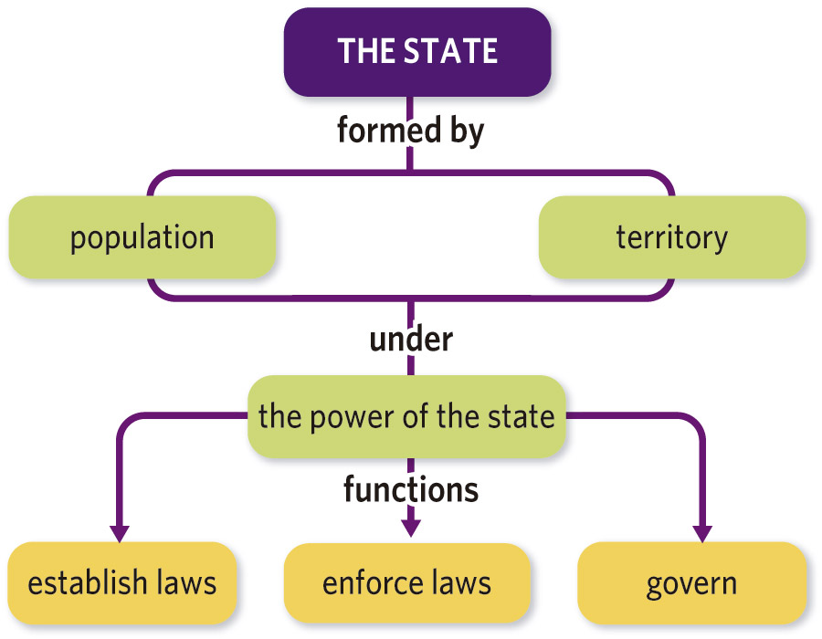
- Collect taxes to pay for services and infrastructure, and to manage the economy.
- Administer infrastructure, such as roads, and services, such as education.

States are associated with the territory they run and govern. State territories are normally defined by borders that separate them from other states and their territories.
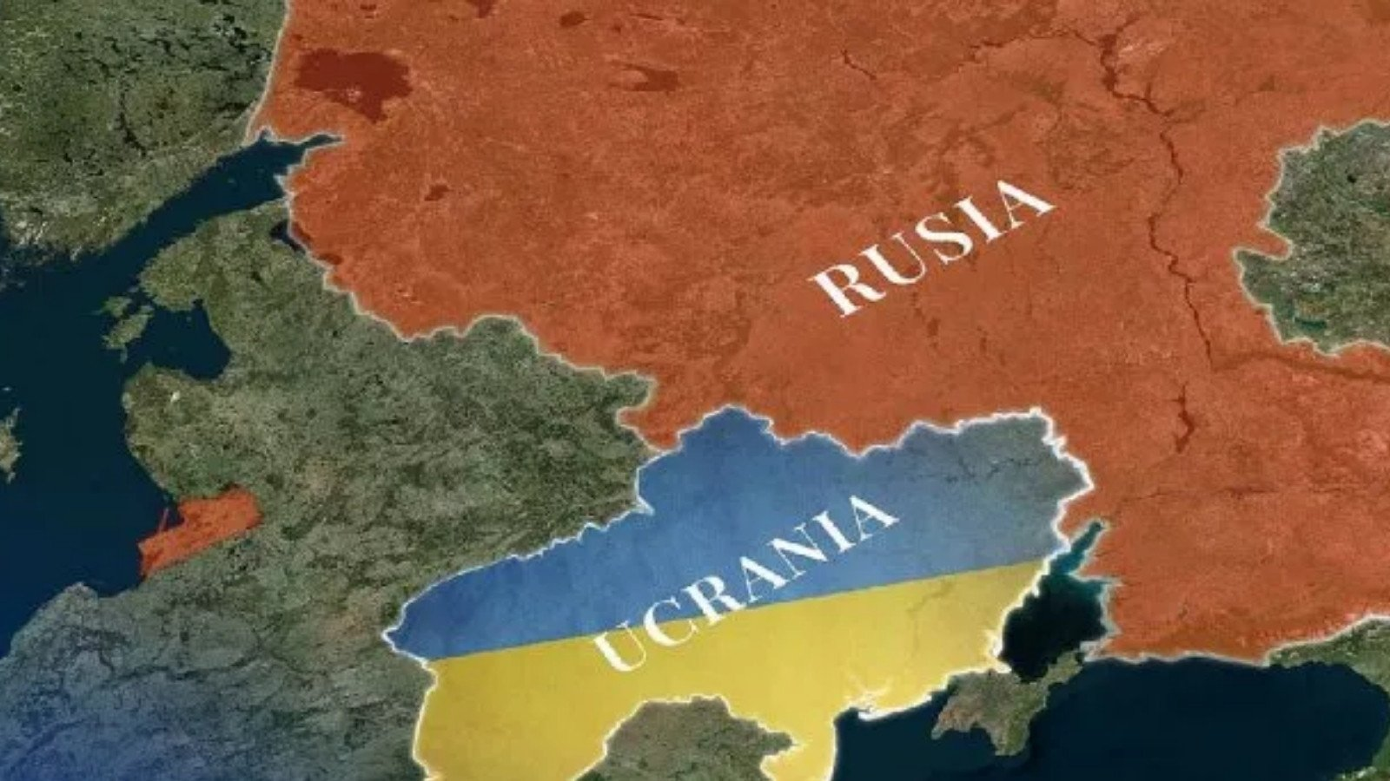
States cannot make decisions or impose them by force outside their borders. If these rules are not respected, conflicts arise between states.
The people living in a state territory have a set of rights and duties that are the same for everyone.
The people who form part of a state do not necessarily share the same social, political and cultural background. It is common for people of different cultures and even different nationalities to coexist in the same state.
For that reason, areas within a state territory sometimes enjoy a certain degree of autonomy or self-governance that differs from the rest of the state's population and territory
What defines a state is the right to power. In the exercise of power, the state performs various functions:
- It establishes the laws that regulate the social relations of the population. In democratic countries, these laws are made in parliament.
- It ensures compliance with laws through the judicial authority.
- It is responsible for maintaining order within the territory and for foreign security through police forces and usually an army.
- It develops foreign policy. In other words, it establishes international relations with other states.
- It collects taxes and uses them to finance public services and general infrastructure. It helps promote equality between the different territories and establishes social security benefits (unemployment pay, pensions, medical care, etc.).
- It runs the economy through laws to regulate business activity and the labour market.
- It provides public services, such as education and healthcare, and manages infrastructure and collective facilities, such as roads, railways, ports, airports, libraries, etc.

1. Democratic and non-democratic states
In democratic states, the citizens elect the government, they participate in government business.
Democracy can either be direct, when citizens meet in assemblies or hold referendums to make decisions. In a representative democracy citizens elect representatives. These elected individuals make up the parliament. In a representative democracy, the people elected through elections form the parliament, which establishes and enacts the laws and chooses the head of government and heads of other institutions.

Democratic elections must be free, plural, apply universal suffrage and be periodical. In democracies, political parties have different views on how to govern. They present their electoral manifesto and their candidates for the citizens to vote on.
Referendums and elections are the two types of mechanisms by which citizens are involved in the exercise of power through voting. This means that in referendums, citizens vote on a particular proposal, whereas in elections, citizens choose their political representatives.
Democracies are governed by the rule of law. In other words, those in authority must respect the laws established by the Constitution. A country's Constitution is the set of fundamental laws that have been passed by citizens voting to determine the form of government, establish the rights and duties of the people, and define the state's institutions and operations.
In democracies, there is separation of powers. No one institution has all the power.
Power is divided into:
a) Legislative power (making laws through parliament). The parliament makes and enacts the laws. It performs legislative functions and controls government action.
b) Executive power (government action). The government determines the policies to be followed by the state and applies them through the administration. It performs executive functions.
c) and judicial power (ensuring laws are applied fairly and correctly). The judicial authority applies the laws. It judges conflicts between citizens and punishes those who do not obey the law. It performs judicial functions.
There are different democratic states:
- Constitutional monarchies: the monarch is the head of state, but does not govern.
- Parliamentary republics: the elected president or prime minister heads the government
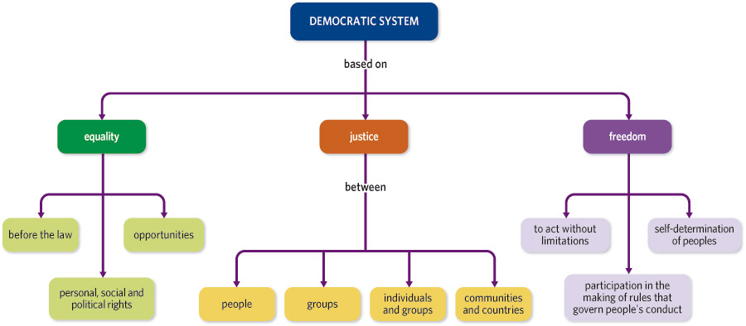
In a democratic state, one person or one group has all the power and governs according to their own interests. Non-democratic states can be:
- Absolute monarchies: the king has all the power. He dictates laws, governs and judges.
- Dictatorships: one person, supported by a political party or the army, has absolute power.

2. The Political organization of Spain
Spain is a constitutional monarchy with a hereditary monarch, where the king is the head of state, but parliament chooses the government. By political custom established by King Juan Carlos since the ratification of the 1978 Constitution, the king’s nominees have all been from parties who maintain a plurality of seats in the Congress. Today the king is the Juan Carlos’ son, Philip VI, (Felip VIè)
The separation of powers ensures that no one authority has too much power. The Constitution divides power into three branches:
- Legislative power: the power to make laws, held by the parliament. The Spanish Parliament is called the Cortes Generales. There are two houses: the Congress of Deputies and the Senate. The Congress of Deputies (Congrés dels Diputats) with 350 members, elected by popular vote on block lists by proportional representation to serve four-year terms, and a Senate (Senat) with 259 seats of which 208 are directly elected by popular vote, using a limited voting method, and the other 51 appointed by the regional legislatures to also serve four-year terms. Voters elect the members of these houses every four years. Citizens participate in politics through political parties
- Executive power: the power to apply laws, held by the government. The Spanish Government is made up of the president (chosen by Congress) and the ministers (chosen by the president), All of them are members of the Council of Ministers (Consell de Ministres)
- Judicial power: the power to enforce laws, held by judges and the courts which are independent of the other branches of power.
The Spanish territory is organized into municipalities, provinces and autonomous communities.
Municipalities are the most basic division of the Spanish territory.. The municipal administration solves citizens’ local problems. A town council governs each municipality with a Mayor or mayoress that is close to the residents and can attend to them quickly. Spain has 8 122 municipalities.

Municipal services
- All municipalities must have public lighting, rubbish collection, road cleaning, a supply of drinking water, sewers, paving, cemeteries, etc.
- Municipalities with more than 5 000 inhabitants must also provide a public park, a public library, a market and a waste treatment facility.
- Municipalities with more than 20 000 inhabitants also have civil protection, social services, a fire brigade, public sports facilities and an abattoir.
- Municipalities with more than 50 000 inhabitants must also provide a transport system and environmental protection.

Spanish territory is divided into 50 provinces. A province is an administrative division made up of municipalities and divide Spain into smaller regions, which are also electoral areas, and helps to municipalities to improve the services that offers to citizens. The provincial council governs the province. The current provinces were created in 1833 using some of the boundaries of the former Spanish kingdoms. The borders have changed very little since then.
The Spanish Constitution was ratified in December 1978. The Constitution recognizes the right to form autonomous communities. Spain is organizationally structured as a so-called Estado de las Autonomías (“State of Autonomies”); it is one of the most decentralized countries in Europe.
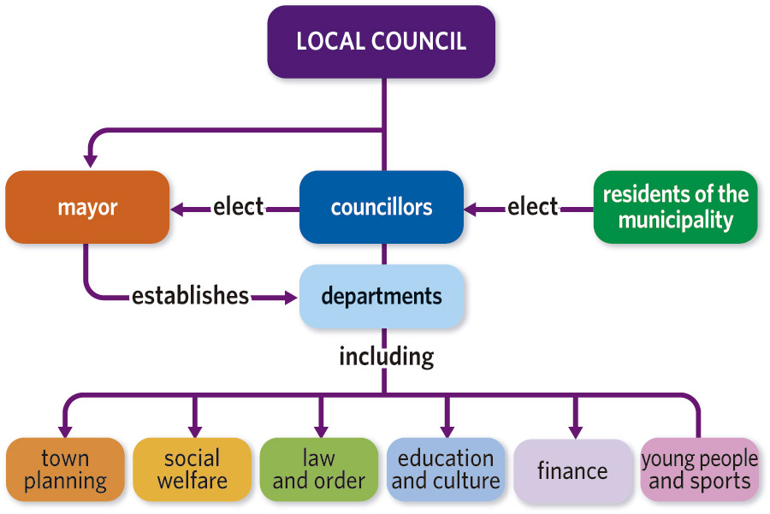

The Spanish State is divided into 17 autonomous communities and 2 autonomous cities, both groups being the highest or first-order administrative division in the country. All autonomous communities have their own elected parliaments, governments, public administrations, budgets, and resources. Health and education systems among others are managed by the Spanish communities, and in addition, the Basque Country and Navarre also manage their own public finances based on foral provisions.
The self-government institutions comprise:
- an assembly or parliament, where laws are debated and passed, the actions of the autonomous government are controlled, the president is elected and budgets are approved.
- the president represents the autonomous community, and forms and leads the government. He or she is elected by the assembly and is appointed by the monarch.
- the government or council implements and enforces the laws passed by parliament and those subject to shared competence with the state. The government is made up of the president and ministers (consejeros).
The basic institutional law of each autonomous community is the Statute of Autonomy. The Statutes of Autonomy establish the name of the community according to its historical and contemporary identity, the limits of its territories, the name and organization of the institutions of government and the rights they enjoy according to the constitution.

3. The European Union
The European Union is a geo-political entity covering a large portion of the European continent. It is founded upon numerous treaties and has undergone expansions that have taken it from 6 member states to 28, a majority of the states in Europe.
Apart from the ideas of federation, confederation, or customs union such as Winston Churchill’s 1946 call for a “United States of Europe”, the original development of the European Union was based on a supranational foundation that would “make war unthinkable and materially impossible” and reinforce democracy amongst its members as laid out by Robert Schumann and other leaders in the Schumann Declaration (1950) and the Europe Declaration (1951). This principle was at the heart of the European Coal and Steel Community (ECSC) (1951), the Treaty of Paris (1951), and later the Treaty of Rome (1958) which established the European Economic Community (EEC) and the European Atomic Energy Community (EAEC). The ECSC expired in 2002, while the EAEC maintains a distinct legal identity despite sharing members and institutions.
After the Maastricht Treaty (1992), the ECC became the European Union with its pillars system, including foreign and home affairs alongside the European Community. Because of this Treaty:
- A single common market was established. In 2002, the Euro (official European currency) came into circulation in the eurozone
- All citizen of the EU were granted European Citizenship.
- A social level and a cultural, educational and environmental policies were adopted by all the EU’s state members
The Maastricht Treaty has been amended by the treaties of Amsterdam (1997), Nice (2001) and Lisbon (2007).
The European Union has supranational institutions that preside over the individual states:
- The European Council is made up of the heads of state or governments of the EU member states. The Council defines the EU’s general political direction and priorities.
- The Council of the European Union: is made up of the ministers from each EU. They can adopt laws and coordinate policies.
- The European Parliament represents the citizens of the EU. Are composed by Euro deputies which are grouped by political parties, not by states. It is elected democratically by universal suffrage. The Parliament has a legislative function and approve EU Laws and EU Budget, together with the Council of the European Union. They also control the European Commission.
- The European Commission is made up of one commissioner from each EU State. They have the executive functions: it ensures that agreements and treaties are enforced, manages the EU budget and
In order to achieve this aims, The EU has set up other European institutions:
- The Court of Justice of the European Union that holds the judicial power and ensures that EU laws are respected and obeyed.
- The Ombudsman is for EU citizens who feel they have been treated unfairly by any European institution.
- The European Central Bank is made up of a president, a vice-president and the governors of national central banks from all EU countries.
The Economic and Monetary Union (EMU) is the integration of various EU member countries into a common market that uses a single currency, the euro, since 1999 (virtually) and 2002 (physically). In this market the freedom of movement of goods, services, people and capital is respected.
Similarly, it aims to implement a common trade policy with countries that do not belong to this common market.
Negotiations on Spain’s entry into the EEC began in 1979. This took seven years, during which time the Spanish economy had to adapt to the mainstream European economy. Since Spain’s integration into Europe in 1986, the country has seen significant social and economic development thanks to EU funds. Projects in Spain financed by the EU include road and high-speed rail networks, education and health programmes, the restoration of historical buildings and the construction of cultural complexes.
Any country that satisfies the conditions for membership can apply. These conditions are known as the ‘Copenhagen criteria’ and include a free-market economy, a stable democracy and the rule of law, and the acceptance of all EU legislation, including of the euro.
In the 2016 referendum the people of the United Kingdom voted in favour of leaving the European Union. The UK has left the EU on 31 January 2020. This process is known as Brexit

Glossary.
STATE
a political association with effective dominion over a geographic area
LEGISLATIVE POWER
one of the three branches of the state which is responsible
for approving laws.
EXECUTIVE POWER
one of the three branches of the state which is responsible for executing laws and managing public affairs.
JUDICIAL POWER
one of the three branches of the state which is responsible for interpreting and applying the law.
SOVEREIGNTY
the authority to rule over an area. In a democracy, the people who have sovereignty.
CONSTITUTION
the fundamental law of a country that shapes the government institutions and rights and obligations of citizens.
DEMOCRACY
form of government in which supreme power is vested in the people and exercised by them.
UNIVERSAL SUFFRAGE
a system of elections where all citizens have the right to vote.
MONARCHY
a political system where the Head of State is the King or the Queen
REPUBLIC
a political system where the Head of State is a president elected by the people

