

Thinking Critque-ly!
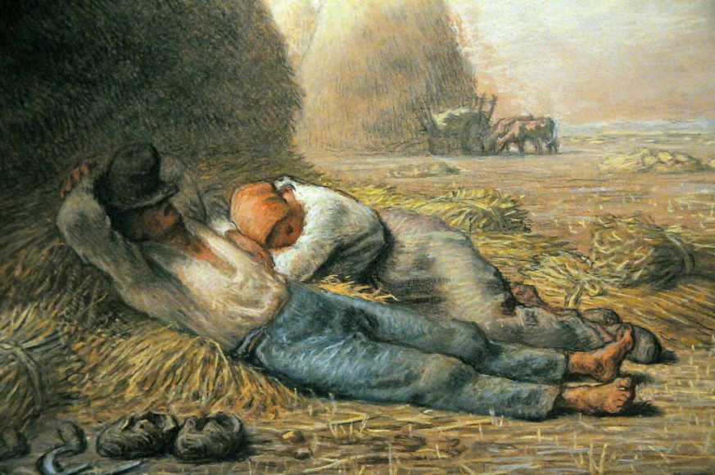
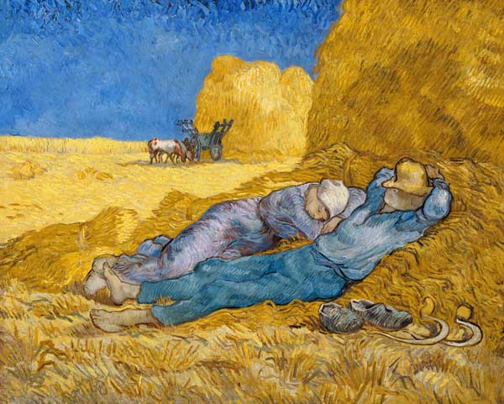
In class, we discussed the Post-Impressionist art period and discussed how color, line and value can affect mood and feelings toward an artist’s subject matter. Look at the two paintings below, Noonday Rest by Millet and Noon: Rest from Work (after Millet) by Van Gogh. Van Gogh was clearly trying to emulate the same subject matter and re-create Millet’s work, however these two pieces when put side by side still look very different and use different colors, lines and values. Write a short 3-5 paragraph essay comparing and contrasting these two works of art. Describe in your own words, how each piece makes you feel and why you think both paintings might make you feel different things, if at all. Make sure you use correct terminology and grammar!

Noonday Rest Noon: Rest From Work (after Millet)
Millet Van Gogh
____________________________________________________________________________________________________________________________________________________________________________________________________________________________________________________________________________________________________________________________________________________________________________________________________________________________________________________________________________________________________________________________________________________________________________________________________________________________________________________________________________________________________________________________________________________________________________________________________________________________________________________________________________________________________________________________________________________________________________________________________________________________________________________________________________________________________________________________________________________________________________________________________________________________________________________________________________________________________________________________________________________________________________________________________________________________________________________________________________________________________________________________________________________________________________________________________________________________________________________________________________________________________________________________________________________________________________________________________________________________________________________________________________________________________________________________________________________________________________________________________

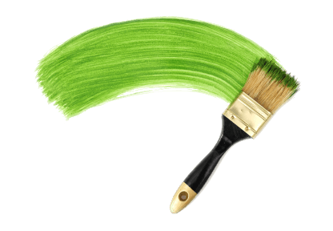
Art Journal

Name: ____________________________
Class: _______ Period: ________

______________________________________________________________________________________________________________________________________________________________________________________________________________________________________________________________________________________________________________________________________________________________________________________________________________________________________________________________________________________________________________________________________________________________________________________________________________________________________________________________________________________________________________________________
(Note: The complete journals given to students will have between 10-15 pages)

