Impressionism Quicksheet
The ‘Impressionist’ style aimed to capture the fleeting transience of light through the use of pure dabs of unmixed color applied in small brush strokes to simulate actual reflected light. It occurred primarily in France between 1867-1886. The term began when a critic used it based on Monet’s Impression: Sunrise from 1872.
Characteristics include:
- Scenes of daily leisurely activities – to capture changing light
- Loose ‘broken’ brushstrokes
- Pastel colors (with blues and violets replacing blacks and browns)
- Lack of a structured composition (as compared to a triangular Renaissance layout)... Random arrangement of figures to capture fleeting moment (inspired by snapshot effect of photography
- Natural lighting – painted
‘en plein-air’ -outdoors

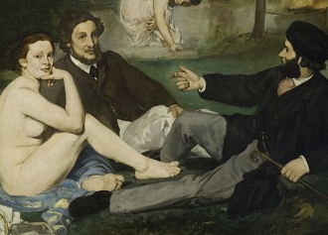 | Edouard Manet  Father of Impressionism – joined the group in 1873, but never stopped using black. His painting Luncheon in the Grass was rejected by the Salon in 1862, but exhibited in the Salon des Refuses, to which it caused shock and controversy.
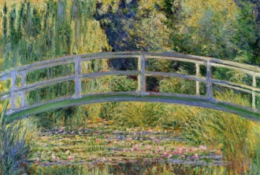 | Claude Monet  Most committed Impressionist painter, repeatedly painted objects over and over, at different times of the day, to observe how light affects color. Impression: Sunrise, Wheatstacks, Japanese Bridge, Rouen Cathedral series.
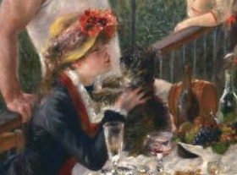 | Pierre-Auguste Renoir  Rosy-cheeked portraits, dappled sunlight, Parisian social settings. Luncheon of the Boating Party, Moulin de la Galette, On the Terrace, Dance in the City / Country.
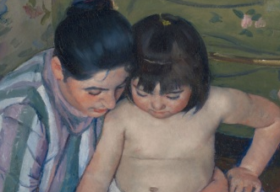 | Mary Cassatt  American-born, exhibited in Paris with the Impressionists – subjects focused on women & children in natural domestic settings. Also influenced by the areas of flat shapes and spaces in Ukiyo-e Japanese prints. Mother & Child paintings.
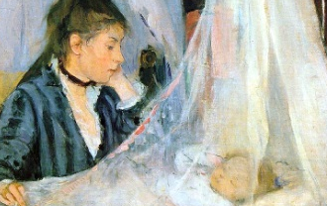 | Berthe Morisot  Sister-in-Law of Manet –exhibited with Impressionists - painted figures of women in interior and outdoor settings – graceful compositions. The Cradle, Grain field.
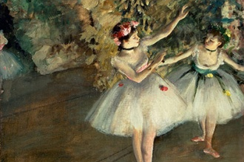 | Edgar Degas  Diagonal compositons, skilled at drawing, pastel, sculpture & painting, Teacher of Cassatt, Racehorses, Bathers & Ballerinas.

