CAUSES OF THE REVOLUTION
- The Russo-Japanese War (1904-1905) Russia and Japan fought for Manchuria. The war was unpopular because of the taxes and the soldier´s recruitment. Russians were defeated because their weapons were outdated.
- New political parties appeared after being illegal. Political parties complained about the lack of rights and hard living conditions.
- The 1905 Revolution when workers in St. Petersburg moved to the Winter Palace. Protesters were shot so this is known as the Bloody Sunday.
Strikes and demonstrations were organized and soviets (workers secret associations) were created. The tsar implemented political reforms including the creation of a Parliament or Duma. But these reforms did not last.
- Participation in First World War. Russia was allied with France and Great Britain. The lack of food and outdated equipment led to continuous defeats which increased discontent.
THE 1917 REVOLUTIONS
There were two revolutions:
- THE FEBRUARY REVOLUTION . Workers in Petrograd protested but this time the soldiers and the peasants joined them. The reasons for the protest were defeats in WW1 and the shortage of food. Nicholas II ordered the army to suppress the riot. However, many of the soldiers refused to fire on the Russian people and the army revolted against the Tsar. Nicholas II abdicated and liberals, Mesheviks formed a provisional government led by Kerensky. There were political reforms but the provisional government failed because they did not withdraw Russia from the War.
Bolsheviks led by Lenin became popular among the soviets.

- THE OCTOBER REVOLUTION
Bolsheviks organized into soviets led by Lenin and Trotsky. They attacked the Winter Palace and the Provisional Government was forced to resign. In October of 1917, Lenin took full control of the government in what is called the Bolshevik Revolution. Russia was now the first communist country in the world. Tsar Nicholas II and his entire family were executed by the Bolsheviks on July 17, 1918.The Council of People´s Commissars led by Lenin and from 1924 by Stalin formed a new government.
The main actions taken by Lenin´s government were:
- Sign of the Treaty of Brest – Litovsk with Germany. Russia had to give large territories to Germany.
- The expropriation and redistribution of the land among peasants.
- The control of industries by the government.
- Bolshevik Party became the Communist Party.
- The Third International was created to control the communist parties all over the world.
In January, 1918 a civil war started. The White Army formed by tsarists and liberals fought against the Red Army led by Trotsky. The Red Army defeated the White Army which was supported by France, Great Britain and Japan.

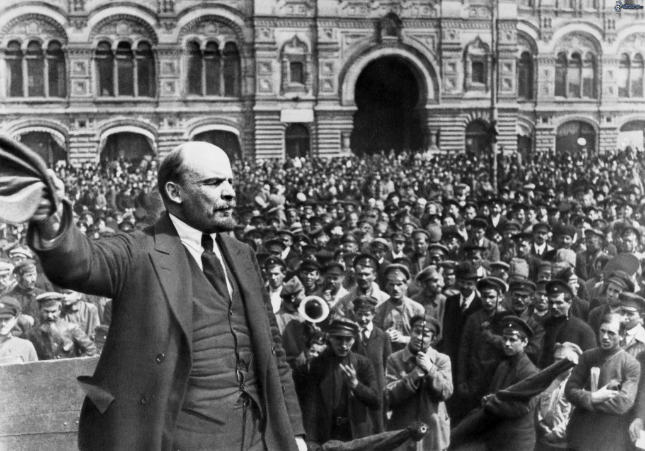

THE CREATION OF THE USSR
- Political organization
The political organization of the USSR implemented the Marxist ideas or communism with the proletariat dictatorship characterized by:
- Power was controlled by the soviets which made the laws.
- The Communist Party was the only political party representing the interests of the workers.
- Economy
Lenin created the New Economic Policy or NEP which mixed communism with capitalism to increase production. The state controlled the industry, foreign trade and banks.
- Territorial organization
The USSR became a federal state including Russia and other Republics such as Belarus and Ukraine. Former regionalist problems were solved with this new organization.
