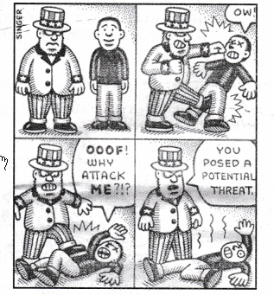

Questions
1. Who has been represented by cartoon wearing cap?
2. What does this cartoon try to speak?
3. Which event can be correlated with this cartoon?
4. ‘You posed a potential threat’. What does this refer?
Answer:
1. The USA.
2. The US hegemony.
3. The US response to 9/11 attack against Al-Qaeda and Taliban.
4. 9/11 attack was an attack on the US hegemony and in response they launched operation Enduring Freedom to teach a lesson to the countries if it is dared to repeat.
3. Study the picture given below and answer the questions that follow:
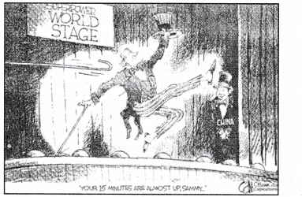
Questions
1. How long do you think the US will stay on the superpower stage?
2. Except China, who can be shown as waiting in the wings?
3. What is being represented in the cartoon?
4. Why China has been represented as waiting in the wings?
Answer:
1. The US will stay on the superpower stage till the rest of the world is resistant with the US and the mega states like China, Russia, India and EU follow the strategy ‘to hide’.
2. Either Russia or India or EU.
3. The well established US hegemony or unipolar world and other countries may be next in the wings.
4. China is a mega-state who can stand at par US hegemony if it accommodates its full potential for the same.

