ROAD TO SECOND WORLD WAR: CAUSES OF THE WAR
The rise of authoritarian regimes
The totalitarian regimes appeared after World War I with expansionist and nationalist policies were one of the causes of World War II.
Mussolini's fascism in Italy and Hitler's Nazism in Germany supported the idea of turning their countries into large empires which led to nationalism.
Communism also spread quickly throughout Europe after the Bolshevik Revolution in Russia. This expansion worried the bourgeoisie.
Consequences of the Treaty of Versailles.
The Treaty of Versailles imposed severe conditions for the defeated countries causing a sense of humiliation and desire for revenge.
This treaty also took a10% of the German territory to be ceded to France, Denmark, Belgium and Poland.

Besides they had to pay harsh reparations which in conjunction with the crisis of 1929 (inflation, currency depreciation, unemployment, etc.), worsened German economy. This context made easier the rise of Hitler.
In Italy, people were dissatisfied with the rewards received for their efforts. At the end of the war, Italy did not receive territories such as Trieste and Istria, which were promised at the 1915 Treaty of London.

GERMANY'S TERRITORIAL LOSSES
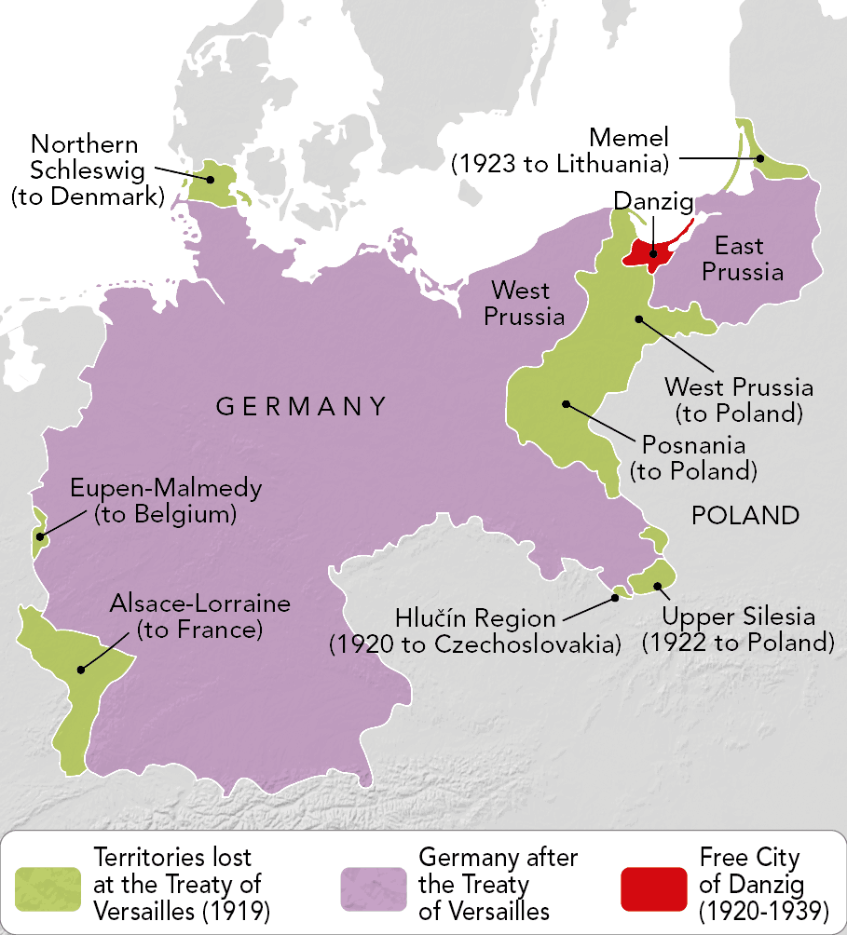

Hitler desired the union of all Germans into a Greater Germany, the abolition of the treaties of Versailles and Saint-Germain and more land and colonies to expand German economy.

Plans of expansion and rearmament
Italy and Germany adopted an expansionist policy to extend their territory. So, they promoted militarism and began an arms race, resulting in an aggressive foreign policy.
Japan, under Emperor Hirohito, strengthened its army to increase its influence in Asia. Their authoritarian policies and expansionist projects brought Germany, Italy and Japan together.
The democratic countries' response to the authoritarian regimes was weak. While the United States adopted an isolationist policy, France and the United Kingdom maintained a policy of appeasement towards Germany.

Expansionist policies
German, Italian and Japanese nationalism and expansionism led to the conquest of new territories in the 1930s.
Ideas supporting this were:
- Germany's expansionist policy. In 1933, Hitler adopted the idea of Pan-Germanism consisting in the reunification of all German-speaking territories, with two objectives: to recover the territories lost under the peace treaties of 1919 and to obtain the raw materials.

- Japan's expansionist policy. The Japanese Empire wanted to become the leading power in Asia and needed 'living space' with raw materials and markets for its products. Then, Japan had to neutralise China, its biggest rival in the region. Japanese imperialism was based on the belief that the Japanese were a superior race destined by God to rule over all other Asians.

GERMAN EXPANSIONISM (1936-1939)
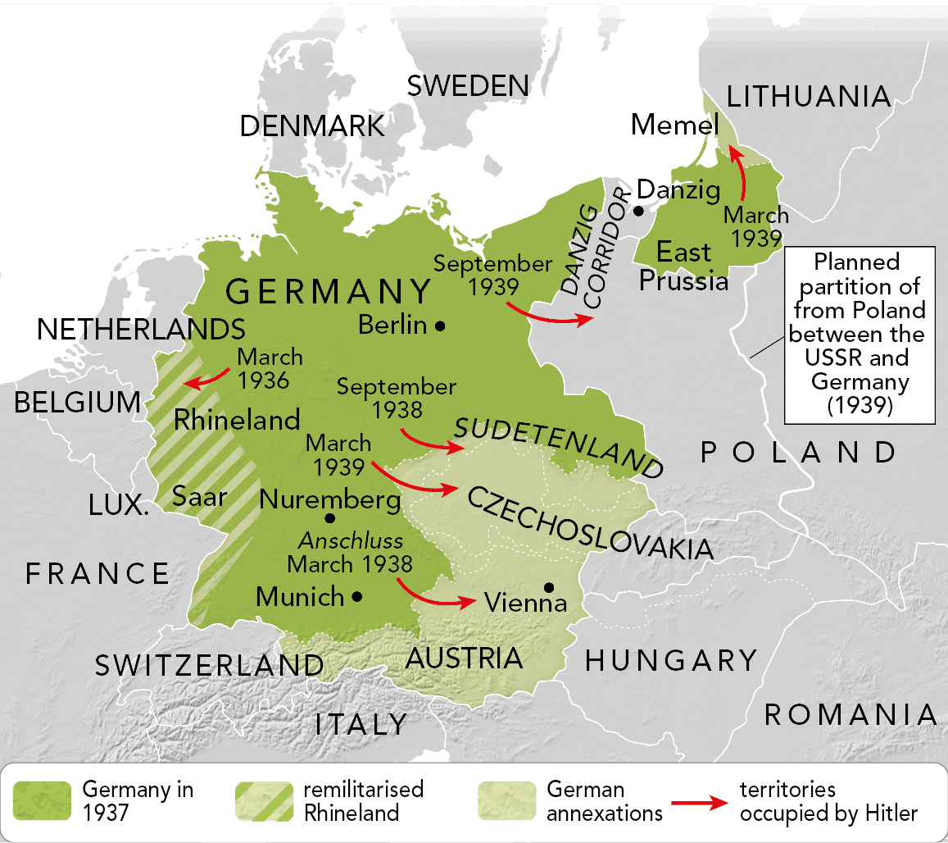

The weakness of the democracies...
The Allies of the First World War decided not to intervene and adopted a policy of appeasement to promote peace and avoid war.
The League of Nations was unable to pacify the member states, and Germany and Japan abandoned the organisation in 1933, followed by Italy in 1936.

JAPANESE EXPANSIONISM (1931-1939)
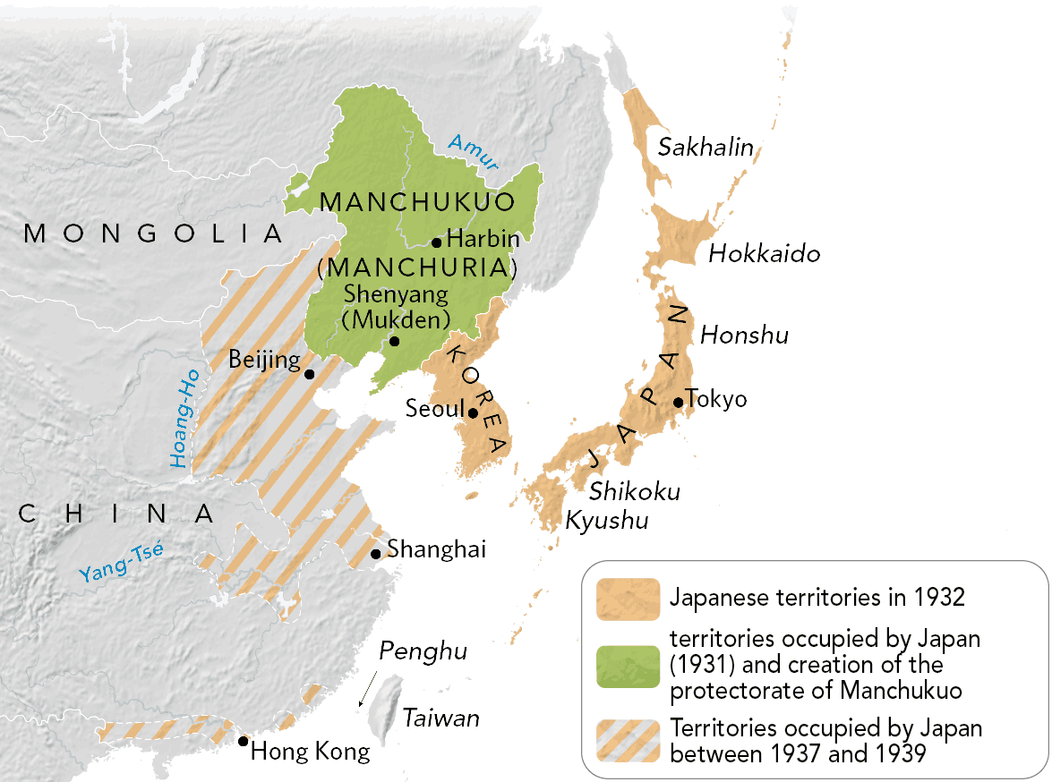

At the Munich Conference (1938), France and the United Kingdom agreed to let Hitler occupy Czechoslovakia.
conflict and aggression increased
In the 1930s, the authoritarian states began attacking other countries.

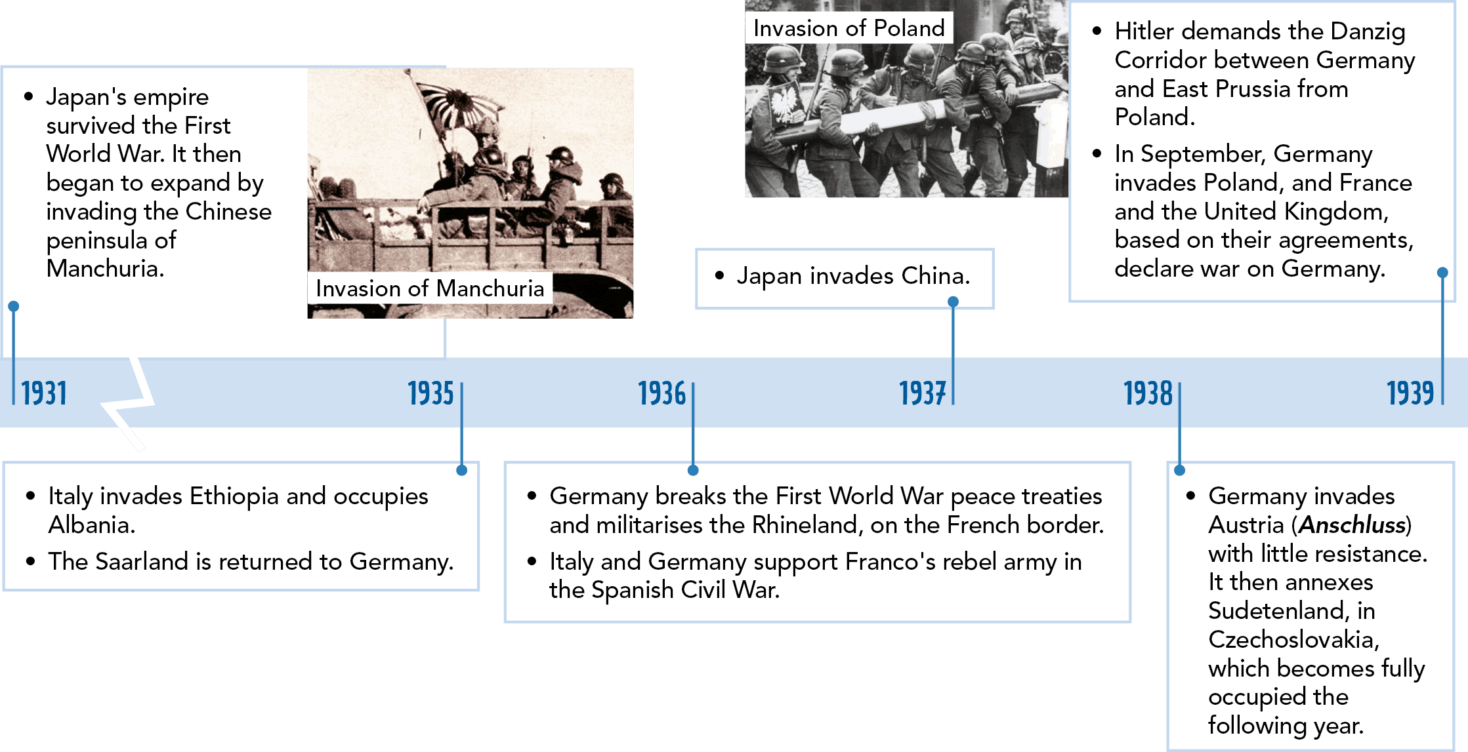
Formation of alliances

This expansionist policy was based on a series of international treaties:

- In 1936, Germany signed an alliance with Italy, the Rome-Berlin Axis.
- In 1936 Germany, Italy and Japan signed the Anti-Comintern Pact, in which they promised mutual support against any attack by the USSR.
- In 1939, France and the United Kingdom signed a treaty to support Poland.
- In August 1939, Hitler and Stalin signed a German-Soviet non-aggression pact. They agreed to divide Poland and assigned Finland and the Baltic States to the USSR.

Germany's invasion of Poland in 1939sparked the Second World War. The conflict was long, spread to several continents, involved hundreds of millions of people and showed humanity the horrors of the contemporary world: the Holocaust (Shoah) and the atomic bombing of Japan, which ended the War in 1945.

PHASES OF SECOND WORLD WAR

PHASE I: THE AXIS OFFENSIVES (1939-1941)

In the beginning, the Axis powers took the initiative. In less than two years, they rapidly invaded much of the world on three different fronts (Blitzkrieg).

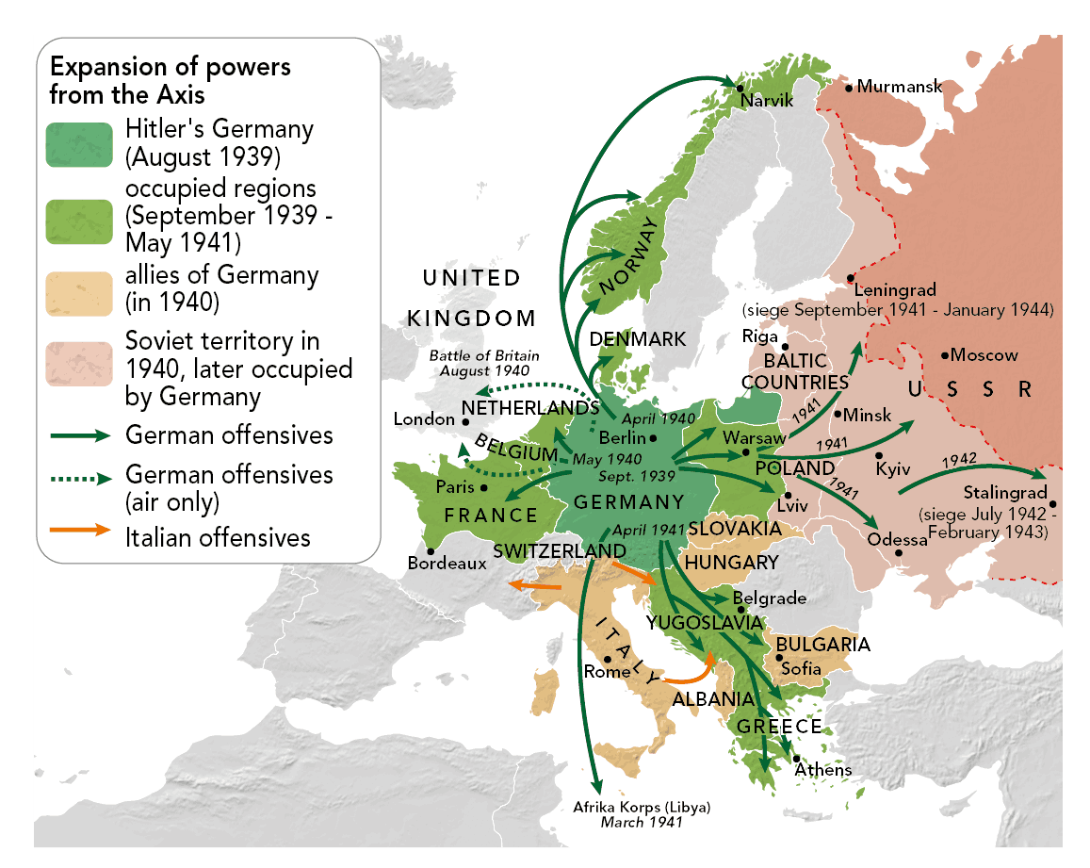
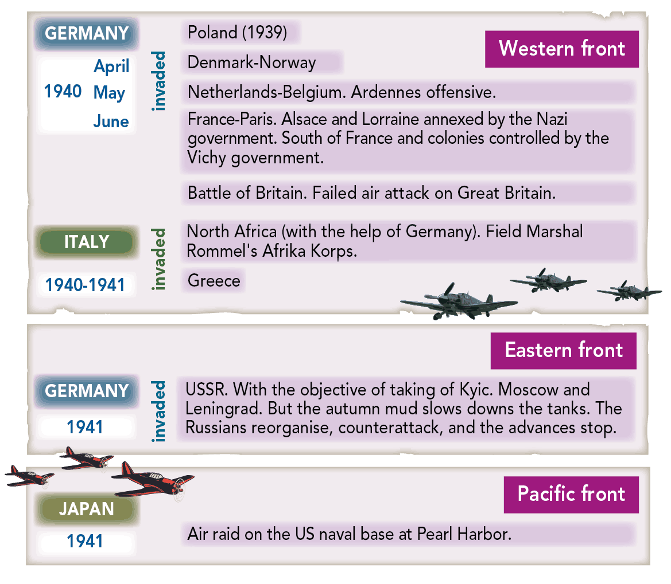
PHASE II: STABILISATION (1942-1943)

The Japanese attack on Pearl Harbor, in the Pacific Ocean, caused the US to enter the War. This led to a period of stabilization.
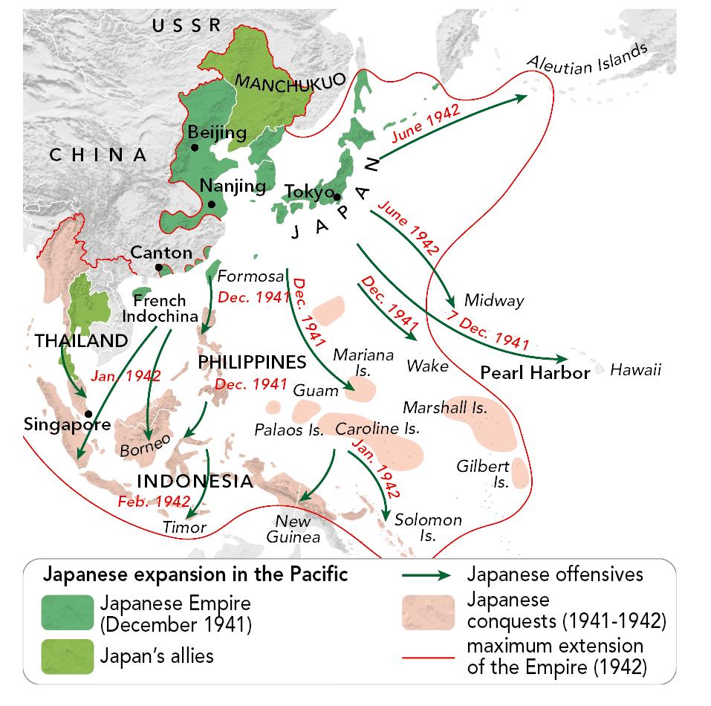
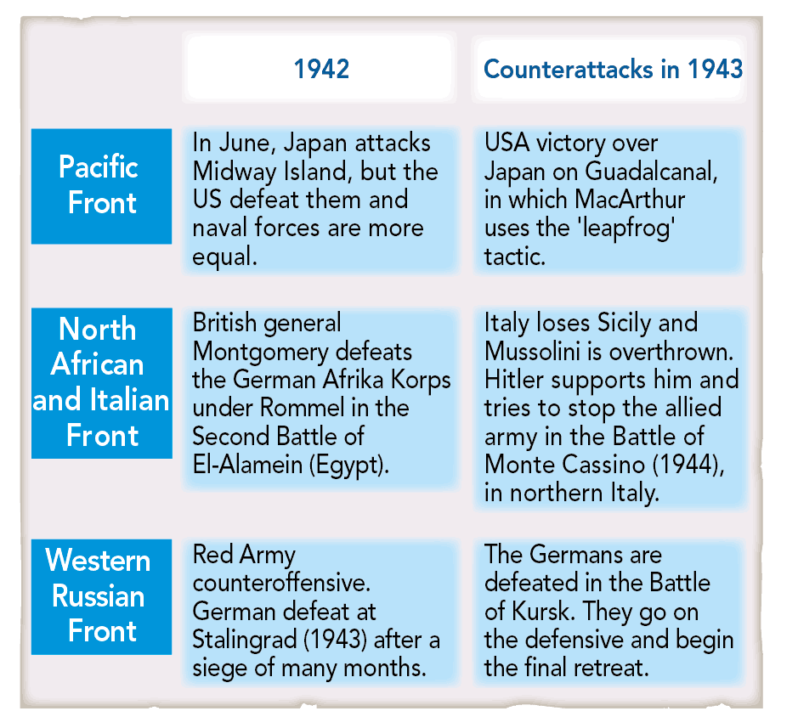
PHASE III: THE ALLIED OFFENSIVES (1944-1945)
The Allied invasion of Normandy on 6 June 1944 was the beginning of the end of the War. Although still a year away, victory was no longer in Germany's reach.
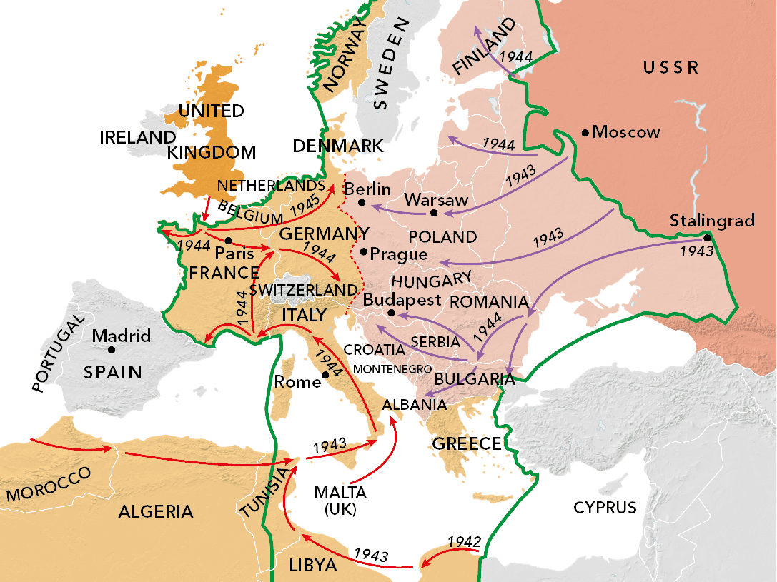
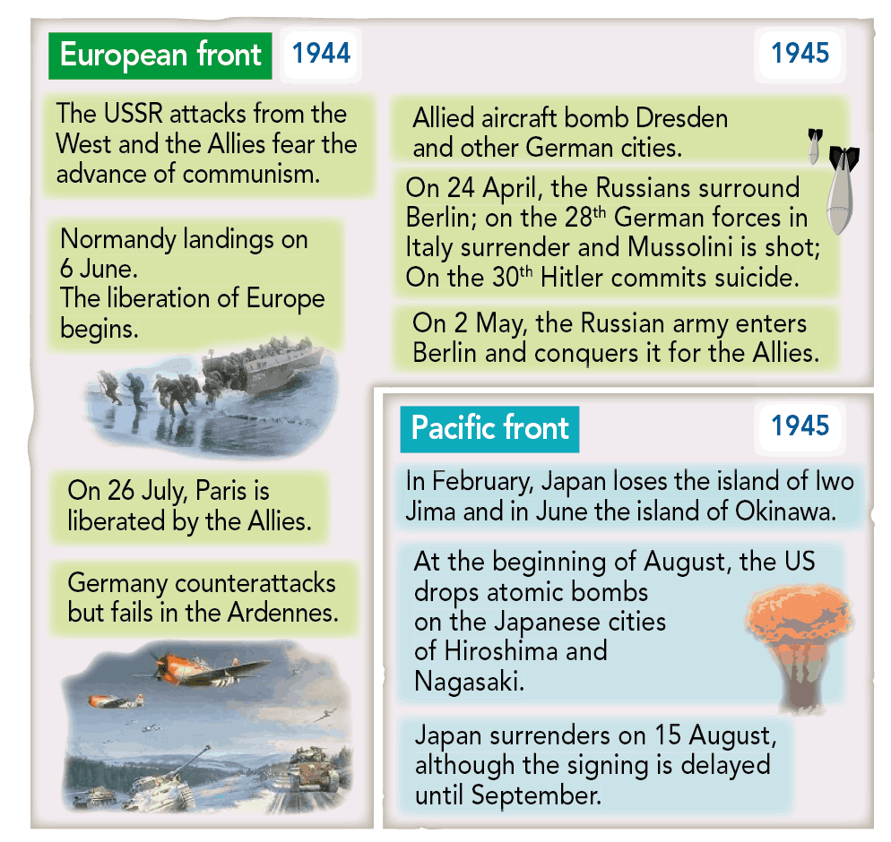

WAS THE SECOND WORLD WAR A 'TOTAL WAR'?

In the Second World War, the only way for both sides to achieve their goals was by destroying the enemy. To do so, they used all means possible. It was therefore a total war not only because of its geographical scope, but most importantly because of the vast number of resources and troops used and its impact on the civilian population. The sides mobilized almost 50 million soldiers from five continents; almost 100 million if we count troops, police, militia, etc.

HOW DID NAZI OCCUPATION AFFECT EUROPE?
For many Europeans, the Germans' systematic use of violence against
civilians made occupation a reign of terror. They suffered political
oppression, human rights violations, ideological or racial persecution and economic exploitation.
The German Gestapo and SS were brutal instruments that exterminated dissidents. Those who resisted were arrested, tortured, deported or executed.

FORCED LABOUR
The aim of German occupation was to obtain economic resources for Germany. Millions of prisoners of war and civilians were also deported to Germany to work in the factories, so that German workers could go to war.

THE EXTERMINATION OF MILLIONS OF JEWS (SHOAH)

Due to their racist and xenophobic ideology, the Nazis committed terrible crimes against people they considered inferior: the disabled, Slavs, Romani, communists and political opponents.
The cruelest example was the Nazi genocide of Jews and other minority groups. In 1942, Hitler implemented the so-called Final Solution, which resulted in the deaths of six million European Jews.
Concentration camps were places of torture, humiliation and death.
Forced to perform hard labor, with little food and clothing, prisoners were tortured, subjected to medical experiments and killed. An estimated three million Romani, Soviet prisoners of war and political opponents, among them 5500 Spanish republicans, also died in these camps.

COLLABORATORS AND RESISTANCE

The Germans found collaborators in occupied countries: collaborationist governments; industrialists afraid of communism or seduced by the possibility of profits.

Despite the danger, many resisted or joined the Resistance. This movement included both men and women, who sabotaged the enemy, spied, hid pilots, etc.

CONSEQUENCES OF SECOND WORLD WAR
Due to their different ideologies and interests, the US, USSR and Great Britain needed time and much negotiating to reach an agreement.
Negotiations mainly took place at the Yalta (February 1945) and
Potsdam (July 1945) Conferences, in which they agreed to:

- the demilitarisation and de-Nazification of Germany.
- the division of Germany and Austria and their capitals (Berlin and Vienna) into four occupation zones.
- the return of all European territories annexed by Germany and the separation of Austria.
- democratic elections in liberated countries and the creation of the UN to keep the peace.
- the Nuremberg Trials, to try war criminals for their crimes.
- the creation of new borders in Europe by giving Poland part of Germany and other territories to Allied countries.

In 1946 and 1947, peace treaties were signed with Italy, Romania, Bulgaria, Hungary and Finland during the Paris Peace Conference.
In 1951, the Treaty of San Francisco was signed between all allies, except the USSR and Japan. The treaty for Austria, occupied by the Allies, was signed in 195
Benefits for the Allies

Most battles were fought in Europe so the continent was devastated, and needed reconstruction.
The biggest winners were the United States and the USSR who emerged as the world's two main powers:
- The USSR extended its territory and influence in Eastern Europe.
- The US did not have its industry and infrastructure damaged. This put it in a strong economic position to lead the recovery and to gain greater political influence.
This turned both countries into superpowers.

RESHAPING THE MAP OF EUROPE
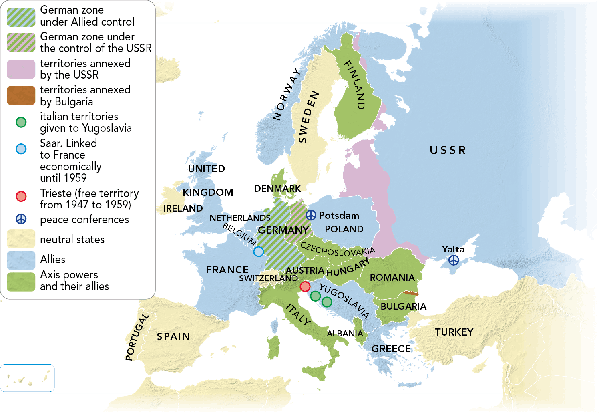
- The USSR annexed Estonia, Latvia and Lithuania, as well as part of Finland (Karelia), Poland and Germany (part of East Prussia). It occupied the Japanese Kuril and Sakhalin islands. It also seized Romania's Bessarabia Region.
- Bulgaria ceded Macedonia to Yugoslavia, and Thrace to Greece.
- Italy lost its colonies, returned the Dodecanese Islands to Greece, and Albania gained independence.
Demographic impact

As well as 6 million murdered Jews, an estimated 60 to 70 million people died. Half as many again were wounded or mutilated, and 3 million people went missing.

To make things worse, most of the military and civilian victims were young people. This aged the population.

The discovery of the Nazi concentration camps, the bombing of Hiroshima and Nagasaki, the Soviet massacres in Poland and the cruel practices of certain Allied forces raised serious questions about the barbarism of Western civilisation.

Economic cost

The War destroyed cities, industrial facilities, fields and transportation routes devastating all the European countries involved.
The cost of the War also led to a huge budget deficit and high inflation.
Most of Japan's industrial facilities were destroyed; Hiroshima and Nagasaki were demolished; and its economy lost 44% of its industrial capacity. Furthermore, the population suffered severe food shortages, inflation and the effects of the black market.

New superpowers
The collaboration between the Allies disappeared after the War. The two superpowers clashed on many issues: the future of Germany, control of atomic energy, the new borders and the governments of the liberated countries.
The presence of British and American troops in the West and Soviet troops in the East divided Europe into two zones with the partition of Germany (and Berlin) into occupation zones under Allied control.
The reconstruction of Europe was influenced by these two superpowers.
USA and USSR represented two opposing economic, political and social systems.

AN IRON CURTAIN DIVIDES EUROPE
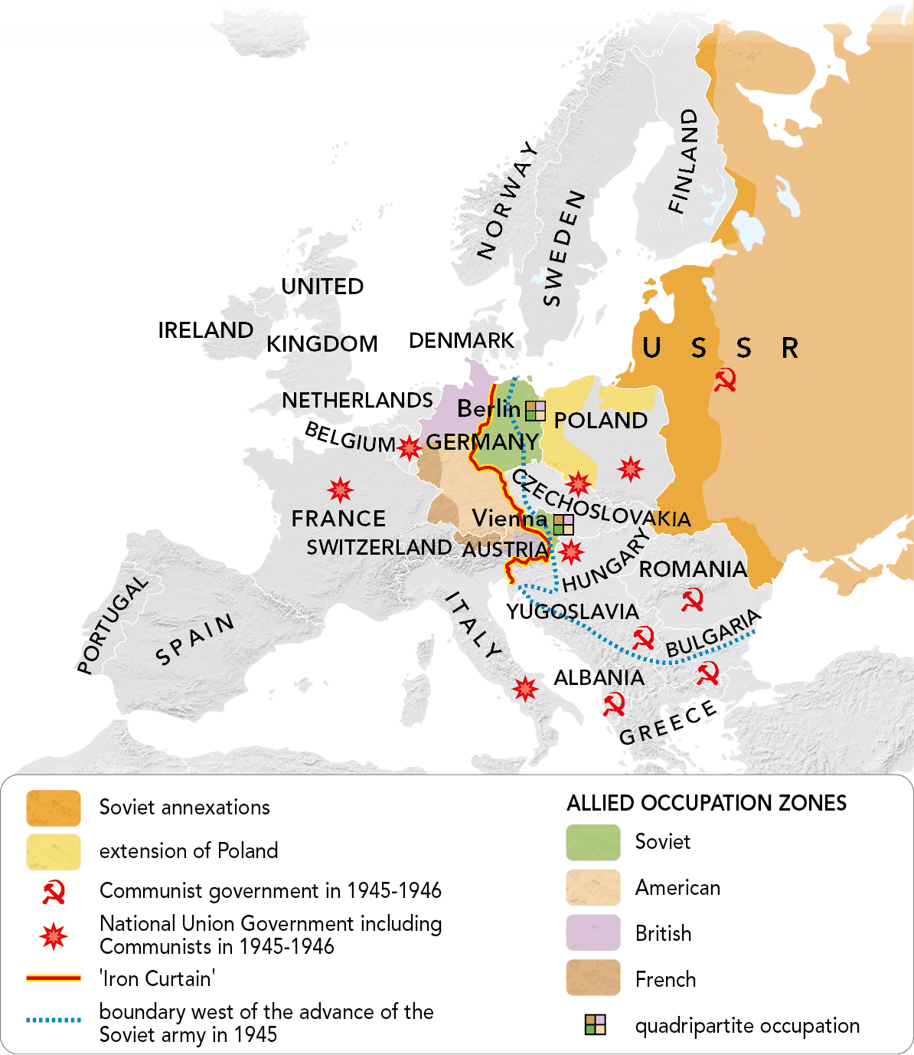
The division of Europe
The USSR established communist governments in the new Eastern European countries.
Stalin declared the capitalist and communist systems incompatible, and Winston Churchill, declared that Europe was divided by an 'Iron Curtain'. This led to the division of Europe in two blocs with opposing interests.
This began what an American journalist called the 'Cold War', which turned this rivalry into a permanent conflict between the two blocs.

NEW INSTITUTIONS FOR THE RECONSTRUCTION AND MAINTAINING PEACE

The League of Nations was formed after World War I to avoid another armed conflict. At the end of World War II, a new organisation was founded by 50 countries.
In 1945, the founding Charter of the United Nations (UN) was signed in San Francisco. Its headquarters were located in New York.
Its main governing body is the Security Council, which has 5 members: the 4 victorious countries from the Second World War and China. They make key decisions or use their power of veto to block them.
They are overseen by a Secretary General, who represents the member countries, which meet each year in the General Assembly. Each country has one vote, but they can only give non-binding guidelines.

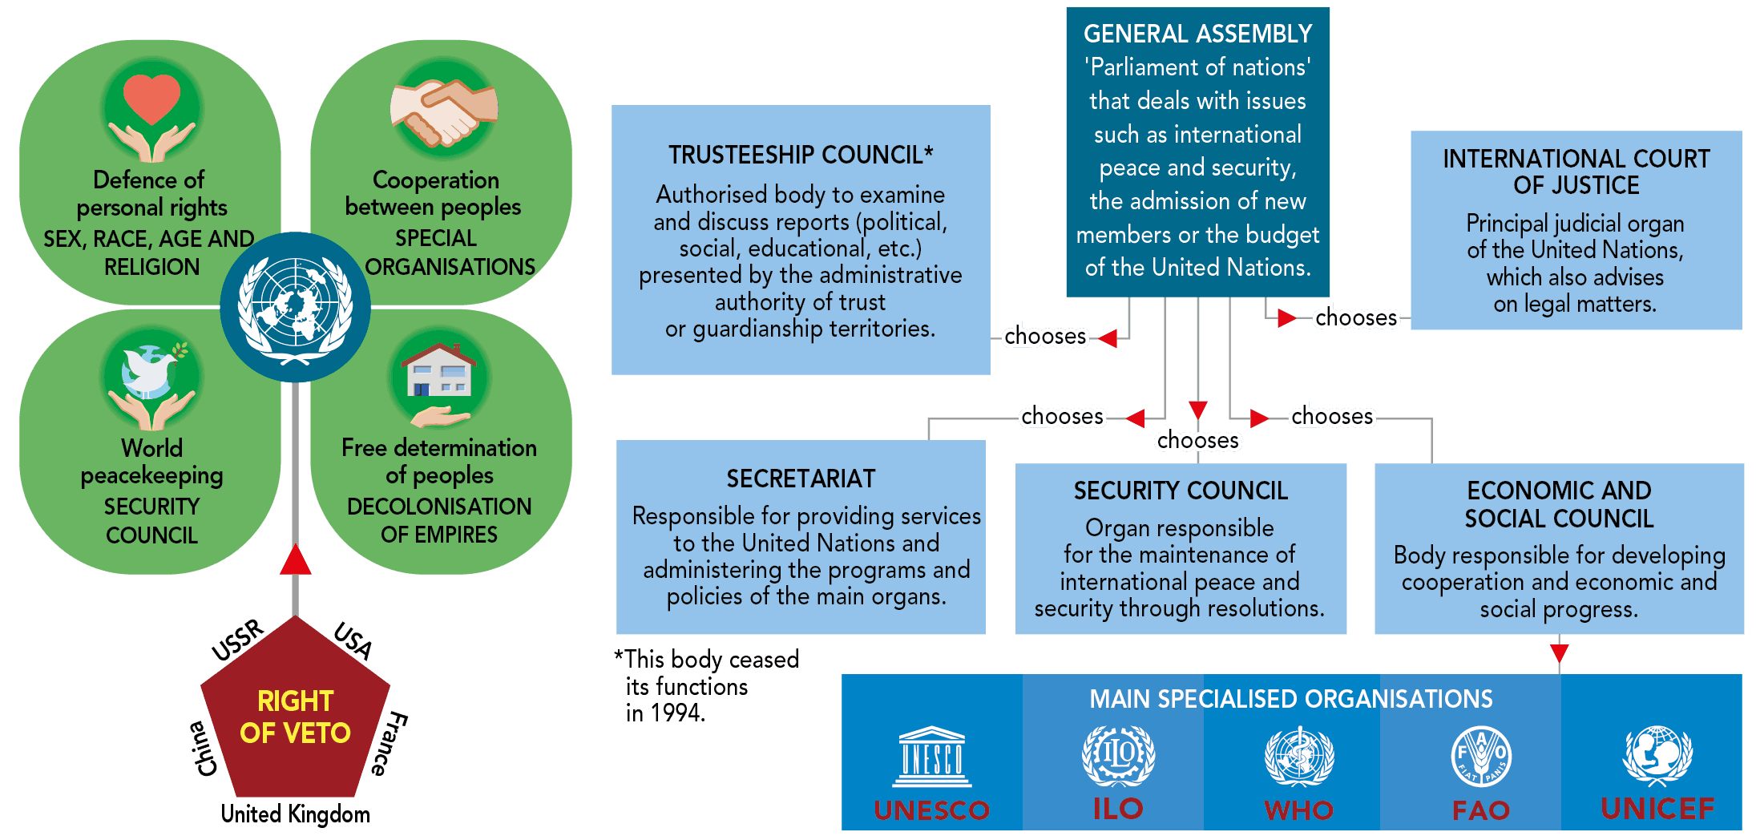

In 1944, 44 allied countries founded the International Monetary Fund (IMF), which, alongside the Bank for Reconstruction and Development (today the World Bank) provided funding and guidelines to promote economic reconstruction in the post-war period.

