NAME: ____________________________ GROUP: ___ DATE: ____________
MRS. SANZ GLOBAL HISTORY YEAR 4
~ SIMÓN BOLÍVAR ~
“The bonds that united us to Spain have been severed.” – Bolívar, The Letter from Jamaica (1814)

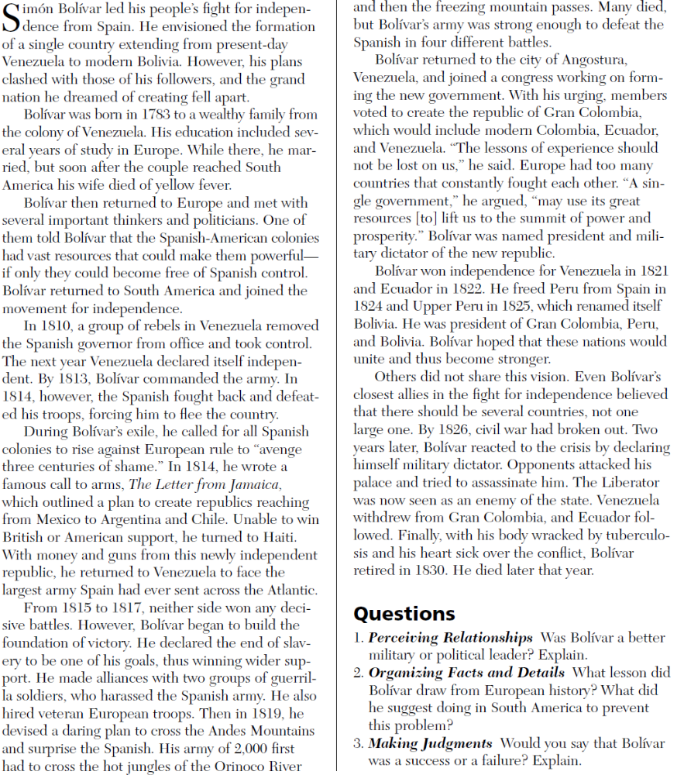
QUESTIONS:
Please answer the following questions on the back of this paper.

1. What lesson did Bolívar draw from European history?
What did he suggest doing in South America to prevent
this problem?
2. What obstacles did Simón Bolívar face while trying to
defeat the Spanish?
3. Who supported Simón Bolívar in his war against the
Spanish?
4. In what ways was Bolívar a success?
5. In what ways did people disagree with Bolívar and his
actions?

