THE CHALLENGE
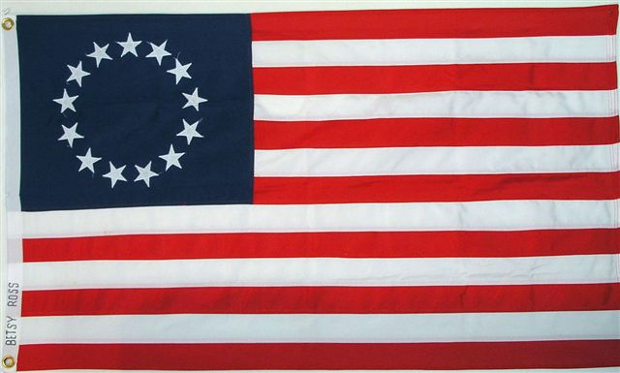
Links: http://www.teachnet.ie/jheffernan/2005/coloniallife.htm
Search Key Words: Revolution, Independence, America
The American Revolution, also referred to as the American War of Independence, refers to the period during the last half of the 18th century in which the Thirteen Colonies that became the United States of America gained independence from the British Empire. In this period, the Colonies rebelled against the British Empire and entered into the American Revolutionary War between 1775 and 1783. This culminated in an American declaration of independence in 1776, and victory on the battlefield in 1781.
The Challenge is to journey through the years of the Revolutionary War using the links provided below. Each page will provide links to web sites that will provide you with the answers. Read through the web pages to answer the questions on the Question Sheet. Once finished with your question sheet, use the information you have learned and read about to make a video about the American Revolutionary War. Good Luck!

QUESTION SHEET

Now that we’ve discovered that we are taking a journey through the Revolutionary War, make sure you are following along to your Question Sheet and answer the questions by using the information on the screen. Use the “Additional Links” to help you with you questions and find out even more information!

1. Who took the throne of England in 1760?
2. When did the Boston Tea Party occur and who were the protesters?
3. What is an act?
4. Where did the First Continental Congress meet in April of 1774?
5. On what date did Paul Revere exclaim “The British are coming!”
6. Which two men lead American troops in the Battle of Trenton in 1776?
7. What was the date of the Hobkirk’s Hill battle?
8. Name Britian’s prestigious General who surrendered in Yorktown in 1781?
9. Which country became allies with America to help defeat the British?
10. When was the American Constitution created?
11. When was the peace treaty signed between Great Britain and the United States?
12. Name the first person to sign the Declaration of Indepence.

Taxation Without Representation
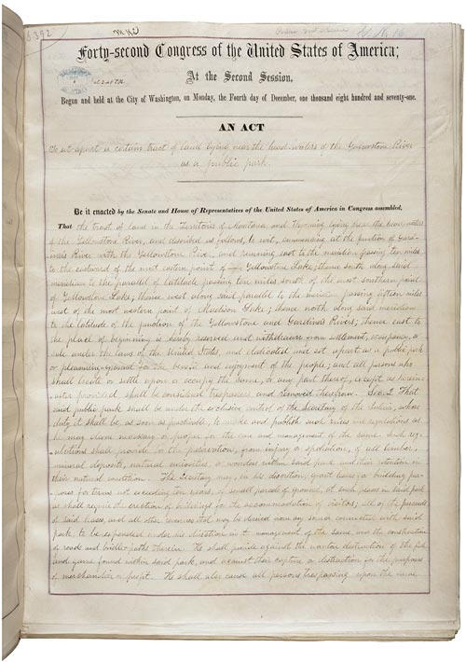
King George III, after taking the throne of Britian in 1760, began placing many new laws against the colonies that were not beneficial to the Americans. It included acts on imported non-British goods called the Stamp Act and also a Stamp Act that allowed the British to tax newspapers, almanacs, legal documents, dice, and even playing cards! This money earned from the taxes would not go to the colonies, but back to their mother land. It was because of these laws and acts passed by the King on the colonies that was one of the main reasons for Americans to begin their revolution.
Links:
http://memory.loc.gov/ammem/collections/continental/timeline.html
http://www.pbs.org/ktca/liberty/chronicle_timeline.html
Search Key Words: American Revolution Forms, Sugar Act, Parliment

REVOLUTION!
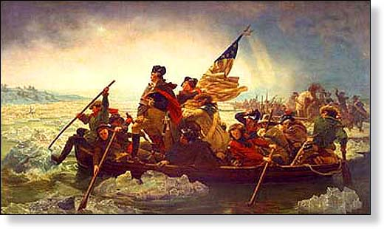
The first colonial opposition to King George III's new acts started in 1764. The colonies used protested and even proceeded with non importation. Non importation focused on not buying English goods from the King's markets. By 1765 these protests quickly became very serious and even organized. These protests continued until 1774. It was on the night of April 18 1775 that Paul Revere made his imfamous Midnight Ride from Boston, Massachusetts to Lexington, Massachusetts to tell John Hancock and Samuel Adams about the British troops who were marching to the same area in order to control ammunition buildings in Concord. This Battle of Lexington and Concord would be the start of the Revolutionary War.
Linkshttp://en.wikipedia.org/wiki/Paul_Revere
http://www.earlyamerica.com/paul_revere.htm
Search Key Words: Paul Revere, Revolt, American Revolution

Victory and Defeat
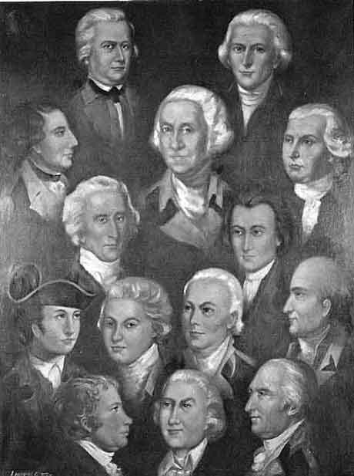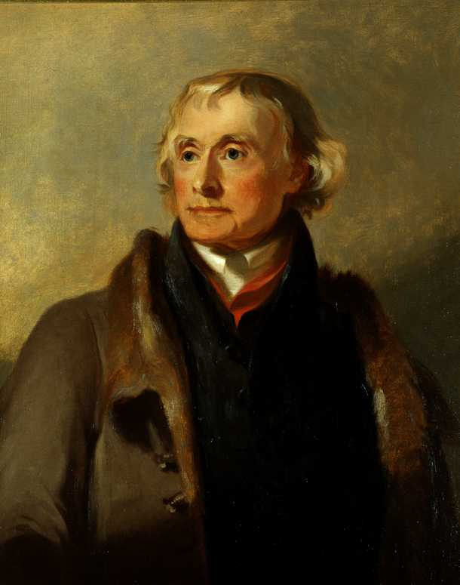
During the American Revolutionary War, British and American soldiers fought on American soil. Their battles too place in both northern and southern colonies. Sons and Fathers fought side by side. The first battle of the revolution took place on April 18, 1175 and finally ending with the Battle of Yorktown of 1781.
Links:
http://www.historycentral.com/revolt/battles.html
http://www.kidport.com/RefLib/UsaHistory/AmericanRevolution/Battles.htm
Search Key Words: American Revolution Battles, George Washington, General Cornwallis

A DECLARATION!
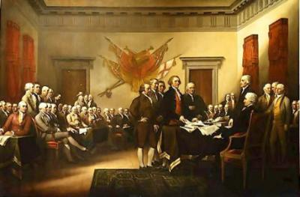
In 1787, the many brave and important Americans meet for The Constitutional Convention. During the convention, the American Constitution was passed. By June 21, 1788 the constitution was ratified by nine states. These nine included: South Carolina, Maryland, Massachusetts, Connecticut, Georgia, New Jersey, Pennsylvania, Delaware, and New Hampshire. The last state to ratify the constitution was Rhode Island, the original colony that did not sign until May 1790.
Links:
http://www.historycentral.com/revolt/Paris.html
Search Key Words: Declaration, Constitution, American

