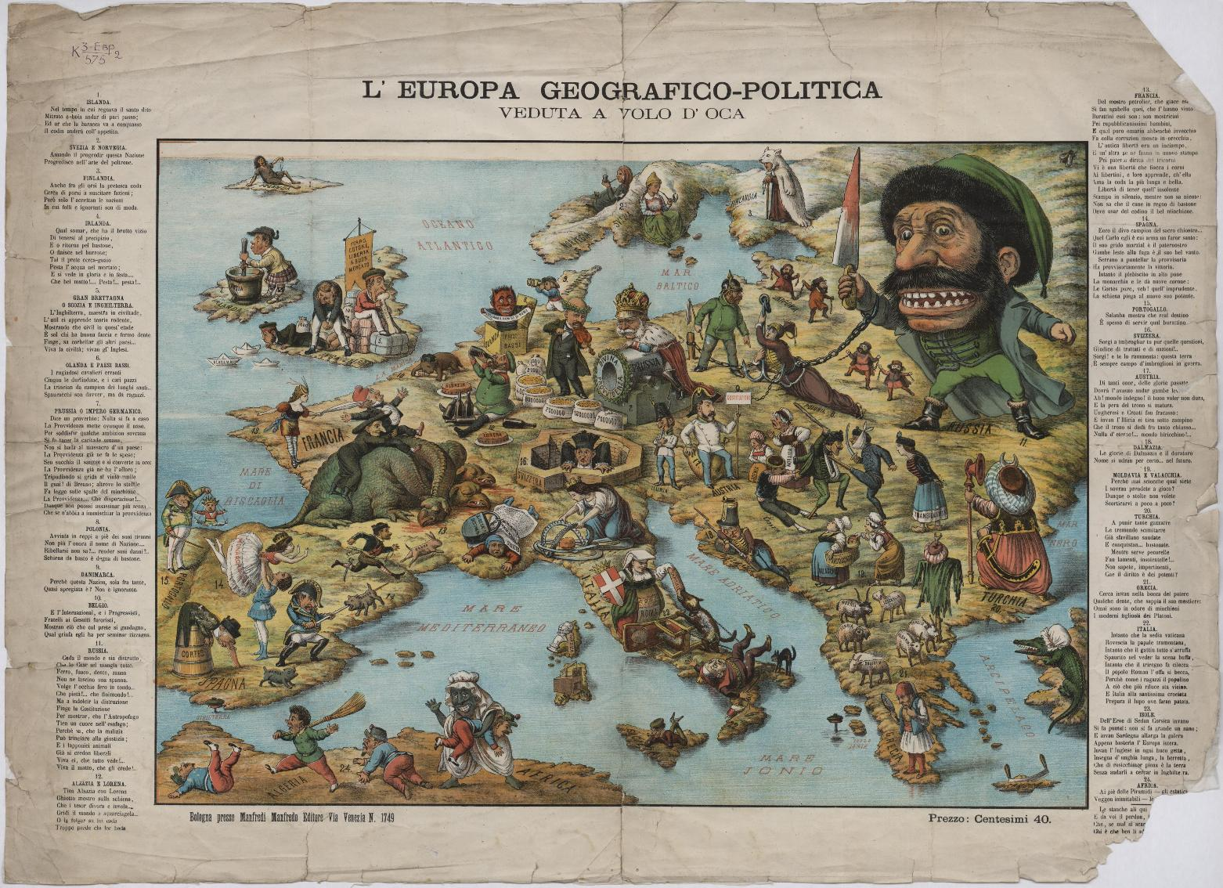

This French satirical cartoon map (‘Carte drôlatique d’Europe pour 1870‘) sought to get some laughs out of those tensions by showing an anthropomorphic map of Europe, where each country was represented by a caricature of its national ‘persona’.
• Prussia, made to look like its walrus-bearded ‘Iron Chancellor’ Otto von Bismarck, is haranguing its neighbours: kneeling on Austria, a sleeping soldier in undress; covering the Netherlands with its right hand.
• France, dressed as a fierce zouave soldier, is aiming a bayonet at the heart of the unwieldy Prussian military monster.
• Belgium, too small to be anthropomorphised, is being squeezed between France and Prussia (which would become its familiar, if uncomfortable lot in the First and Second World Wars).
• England is an old woman, struggling with Ireland, her rebellious lapdog on a leash (although it looks more like a small bear); Scotland is the old lady’s mobcap.
• Spain is a rotund senorita, smoking the day away while lying on her back and thus nearly crushing the small Portuguese soldier under her.
• Corsica and Sardinia are joined to show a leprechaun-like figure gleefully mooning the map-reader.
• Italy, possibly made to look like the great national leader Garibaldi, is holding off pressure from Prussia.
• Denmark is a small, swaggering soldier, no doubt hoping to recover Holstein, the territory it lost to Prussia in a war a few years earlier.
• Norway and Sweden are together turned into a ferocious dog.
• Switzerland is a closed cottage.
• Turkey in Europe is “an Oriental crushed by the superincumbent pressure of the other countries”.
• Turkey in Asia is a girl smoking a hookah pipe.
• Russia is a rag-collector in a patched coat, ‘Crimea’ written on the patch sewn on last.
The Degrees of Longitude at the bottom of the map are measured in rifle-lenghts – another comment on the explosive military situation.

