LIBERAL REVOLUTIONS
REVOLUTIONS IN 1830
After the Congress of Vienna, liberalism and nationalism became popular in Europe.
Based on these ideas, several revolts broke out in. The Revolution began in France where Charles X, an absolutist king, was deposed and replaced by Louis Philippe of Orleans who established a constitutional monarchy.
A revolution against the serfdom that prevailed in the Russia took place in Poland, although it was harshly repressed by the tsarist army.
THE SPRING OF THE NATIONS OR THE PEOPLES
The revolutions of 1848 are known as the Spring of the People since they were the beginning of the unification processes of Italy and Germany, as well as the basis for the independence of peoples under the Russian, Austrian and Ottoman empires. The most important revolts took place in Vienna, Hungary and the Austrian territories in Italy and Germany.
However, the most successful revolution took place in France.
In Paris, the people revolted against Louis Philippe of Orleans who had suppressed the national workshops and had left many workers unemployed. This combined with the economic crisis, worsened their standard of living.
The Second Republic was proclaimed and liberal ideas such as universal male suffrage, freedom of the press and some social rights triumphed.
Elections were called and won by Louis Napoleon Bonaparte and in 1852 he was proclaimed Emperor, creating the Second Empire until his abdication in 1870.
The revolutions of 1848 meant the triumph of democratic principles such as universal male suffrage and the social rights that would be imposed. in Europe throughout the second half of the 19th century.
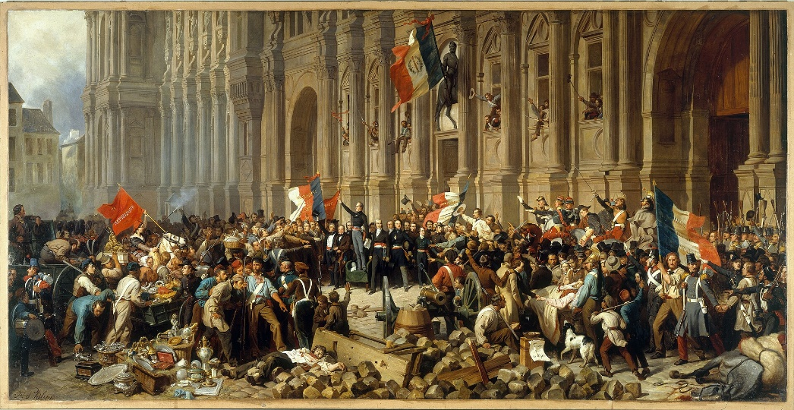
NATIONALISM
Nationalism is defined as the right of nations to become sovereign states with their own government and territory. Nationalism spread throughout Europe as a fight against the Napoleonic invasions. We can distinguish two types of nationalism:
• Unifier of several areas dependent on various states or empires.
• Independence from different states or empires with a different culture or religion.
INDEPENDENCE OF GREECE
The Greeks fought for their independence from the Ottoman Turkish Empire. They had to pay high taxes and were dominated by a minority with a different culture and religion.
The Greeks proclaimed their independence in 1822, but it was not recognized by the Turks. Then the war for independence began. The Ottoman Empire was defeated in 1827 by a coalition of Greeks, British and French. The independence of Greece was recognized in 1830 by the London Conference.

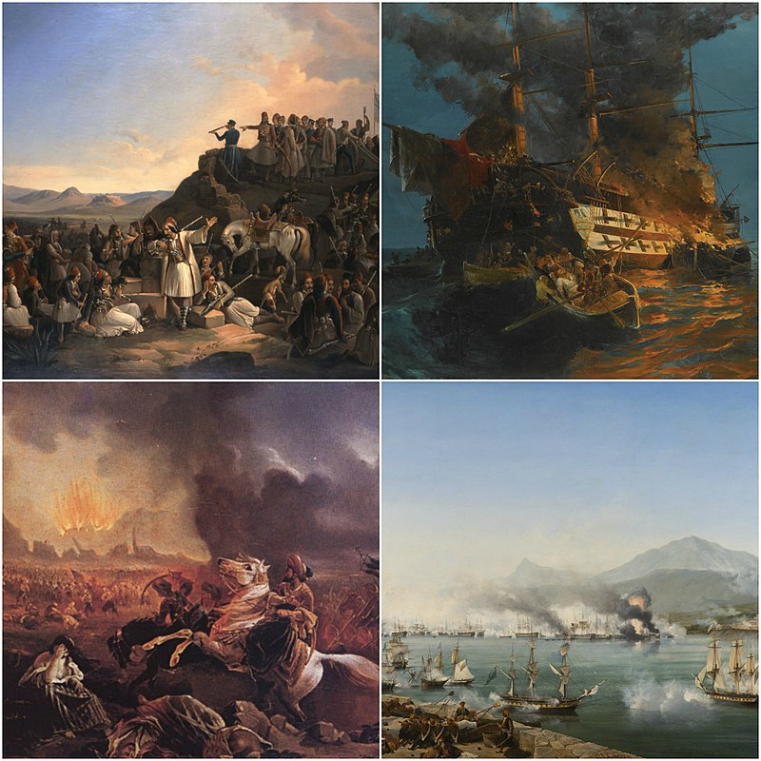
INDEPENDENCE OF BELGIUM
Belgium was part of the kingdom of the Netherlands since the Congress of Vienna. However, Dutch and Belgians have a different culture and religion.
The Belgians felt underrepresented in that monarchy, so they proclaimed their independence in 1830. A war for liberation broke out and Belgium achieved its independence in 1839 under a constitutional monarchy led by Leopold I.
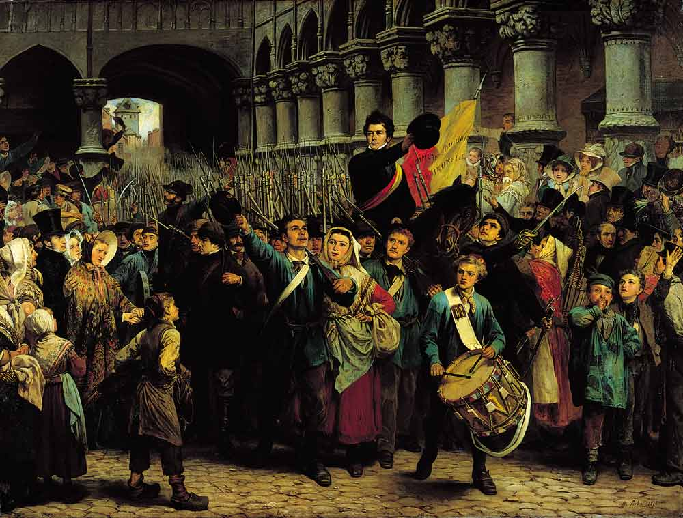
ITALIAN UNIFICATION
Italy was divided into several states, the most important being the Kingdom of Piedmont-Sardinia, the kingdom of the two Sicilies, the Papal States and the northern territories linked to the Austrian Empire.
Italian unification began in the kingdom of Piedmont Sardinia where Victor Emmanuel II of Savoy and his prime minister Cavour.
Cavour, declared war on Austria, recovering Lombardy, while Garibaldi conquered the kingdom of the Two Sicilies by deposing the Bourbons.
Thus, the kingdom of Italy was formed, which was joined by several states in the North, including Venice. Likewise, the Papal States, except for Vatican City, which were annexed in 1870.

GERMAN UNIFICATION
Germany was divided into several states, the most powerful being Prussia and the areas under the rule of the Austrian Empire.
Prussia established a customs union known as the Zollverein in 1834 that escaped Austrian control.
In 1861, William I became king of Prussia and Otto von Bismarck his chancellor. Then, to control of the territory they were engaged into 3 Wars:
- They defeated Denmark, which allowed them to incorporate Schleswig and Holstein (1864);
- Austria (1866), which had to give up its claims to the Germanic Confederation;
- and France (1871), in a war that united all Germans.
In 1871, Wilhelm I was proclaimed kaiser (emperor) of the German Second Reich (Empire).

