CAUSES OF THE FRENCH REVOLUTION
In 18th-century France, most people were peasants. They cultivated land belonging to the nobility and clergy, and paid taxes and rents to the king, the nobles and the Church. This made it difficult for them to survive, when harvests were bad. They began to protest against rents and wanted ownership of the land.
There were also protests in the cities. Workers and artisans had difficulty surviving, and the bourgeoisie (merchants, manufacturers, etc.) were subject to regulations limiting their activities.
The ideas of the Enlightenment and the American Revolution inspired them to demand a series of changes:
- Economic: the right to own property, the freedom to produce, buy, sell, etc., to favor the activities of the bourgeoisie.
- Political: equality before the law, the right to participate in politics, etc. They wanted national sovereignty, where power comes from the people through elections.
Discontent spread through these groups, who represented 95 % of the population and made up the Third Estate or non-privileged estate. The other 5 % (nobles and the Church) did not pay taxes, had manorial rights and were opposed to any change.
PARLIAMENT CALL
By 1788, the king needed money to maintain his standard of living and to pay state debts. The only solution was for the privileged groups to pay taxes.
In May 1789, Louis XVI convened the Estates General to approve a tax reform. The Third Estate called for the suppression of feudal rights and the establishment of national sovereignty, while nobles and the clergy defended their privileges and opposed reforms and new taxes.
The Estates General was the meeting of the representatives of the three estates (clergy, nobility and Third Estate) of the Ancien Régime.
THE REVOLUTION BEGINS…
The demands of the Third Estate were ignored. Voting was done by estate, and the privileged always imposed their will by combining their two votes. The representatives of the Third Estate decided to abandon the meeting, form the National Assembly as representatives of the entire nation and cast individual votes.
In a pavilion in Versailles, they decided to build a new political system based on the will of the majority. They promised to remain there until a constitution was approved.
The privileged estates threatened to use the army. It was then that the people of Paris intervened. On 14 July, they stormed the Bastille, a symbol of absolutism.
This showed that the monarchy was vulnerable to the action of the people. Similar events occurred in other cities. In the countryside, peasants rebelled against the aristocracy, burning farms and palaces. The Revolution broke out.
THE PHASES OF THE FRENCH REVOLUTION
The French Revolution was a long and complex process. Different ways of organizing the state were put into practice:
- The constitutional monarchy (1789-1792). A section of the bourgeoisie hoped to reach an agreement with the king and the privileged sector. It aimed to remove the Ancien Régime and impose moderate liberalism.
- The social republic (1792-1794). The radical bourgeoisie and the popular sectors proclaimed the republic. These groups attempted to make society democratic (universal male suffrage and social laws).
- The bourgeois republic (1794-1799). The moderate bourgeoisie gained power again to subdue the more radical political groups (moderate liberalism).

THE CONSTITUTIONAL MONARCHY
The National Assembly was consolidated as the new power. It was formed from the Third Estate and included some nobles and clergy. They considered themselves the representatives of the new nation, where everyone was considered a citizen.
Some initial revolutionary measures were taken, and important changes were introduced:
- The decree abolished the privileges and manorial rights of the nobility and the clergy.
- The approval of the Declaration of the Rights of Man and of the Citizen established new rights and freedoms. However, these excluded women and slaves.
THE FIRST CONSTITUTION - 1791
Elections led to a new National Constituent Assembly passed a constitution (1791). It was the first in contemporary France and would greatly influence European nations. It included the following:
- The State was organized through the separation of powers (legislative, executive and judicial),
- It recognized equality before the law, rights and freedoms, and established that sovereignty belonged to the people.
- The exercise of this sovereignty was limited by census suffrage. Only men over 25 years of age with a certain level of wealth could vote.
The parliamentary monarchy in France was inaugurated and the Legislative Assembly was elected.
The new representative Assembly approved a series of laws and regulations that continued to build a liberal society. Guilds were abolished and economic freedom and tax reform were implemented.
The Church was forced to accept the Constitution. Its properties were expropriated and sold to individuals to reduce its economic power. In return, the state maintained the religion and the clergy.
To defend the Revolution against the absolutists, a new army was created called the National Guard.
THE CONSTITUTION OF 1791
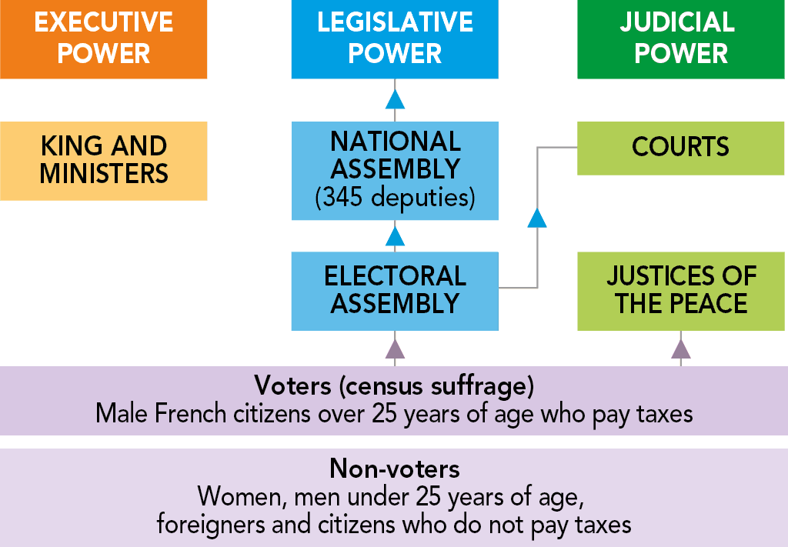
CONSPIRATION AGAINST THE CONSTITUTIONAL MONARCHY
France was a constitutional monarchy but this was rejected by the royal family and by privileged groups. They conspired against the new regime. Many nobles got the support of absolute monarchies, especially Austria and Prussia, to put an end to the Revolution.
King Louis XVI tried to escape France in June 1791 to lead the counter-revolution, but he was recognized and arrested in Varennes, and forced to return to Paris. He was then considered a traitor to the country.
In 1792, the National Assembly declared war on Austria and Prussia. The military could not stop the advance of the Austrian army, which reached the gates of Paris in July 1792.

THE SOCIAL REPUBLIC
The betrayal by the king and the military invasion provoked a new insurrection of the popular classes of Paris (the sans-culottes). In August 1792, the king's residence was stormed and King Louis XVI and Marie Antoinette were imprisoned.
Elections were called to elect a new constituent assembly and the National Convention was formed. It proclaimed a republic, abolished the monarchy and achieved a military victory over the Austrian and Prussian armies at Valmy.
The most radical stage of the Revolution began. There were now two groups of deputies:
- The Girondins. They formed a first government and represented moderate Republicans.
- The Jacobins. They represented the most radical sectors, linked to the sans-culottes.
EXECUTION OF LOUIS XVI AND MARIE ANTOINETTE
There was an intense debate about what to do with the King and Queen. They were accused of treason and executed on the guillotine in 1793.
The death of the monarchs intensified the division among the revolutionaries.
As counter-revolutionary revolts grew, European powers became alarmed. Great Britain, Holland and Spain joined Prussia and Austria to fight against France and put an end to the Revolution.
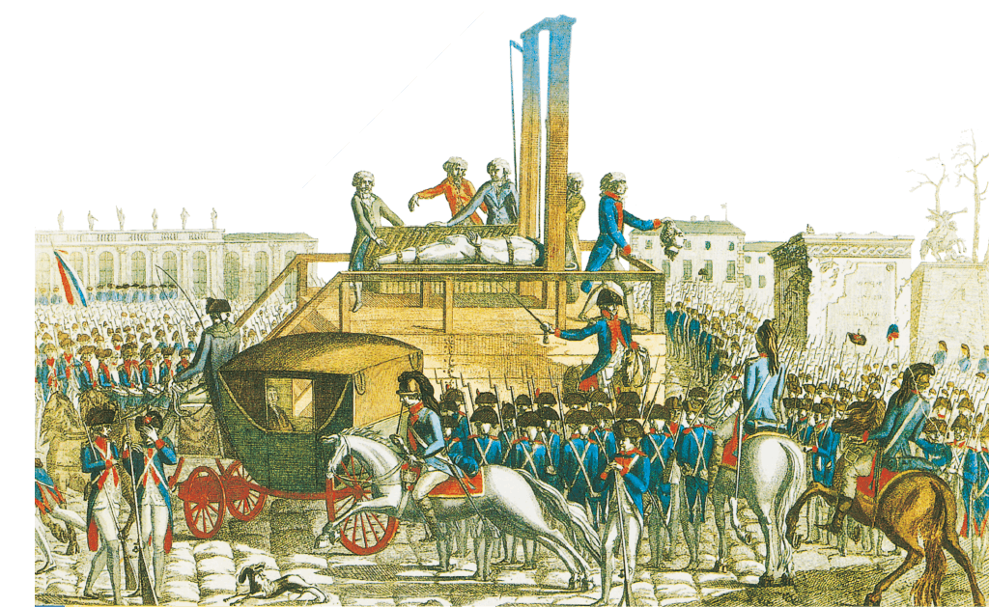
THE REIGN OF TERROR
In June 1793, the Jacobins, with the support of part of the bourgeoisie and the sans-culottes, came to power. They passed the Revolution's most radical measures. To deal with royalist threats, power was concentrated in the Committee for Public Safety, led by Robespierre.
Robespierre created a new type of army based on compulsory incorporation, which managed to stop the threat from abroad.
A new constitution with a new Bill of Rights (1793) was approved. It defended what we now call social rights (to exist, to work, to receive an education, to receive public assistance, etc.).
The Jacobins implemented reforms such as compulsory education, the redistribution of land to the peasants, the setting of a maximum price for basic necessities and a minimum wage.
However, they also suspended rights and freedoms, and created a violent, dictatorship. During this Reign of Terror, the Revolutionary Tribunal punished anyone suspected of opposing the Convention (Law of Suspects) with prison, or death by guillotine.
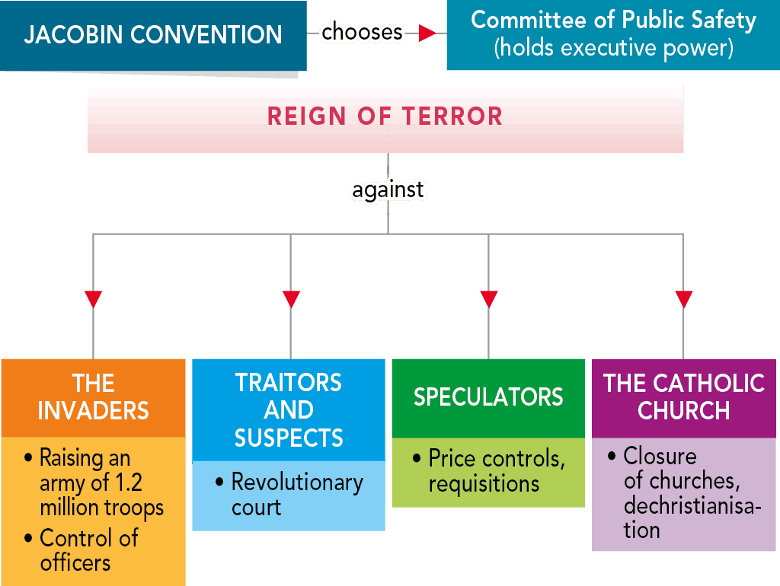
THE BOURGEOIS REPUBLIC
The victories against the European armies and improved living conditions for the popular classes could not consolidate the Jacobin Convention.
Rejection of the social laws and the Reign of Terror as well as arbitrary arrests and uncontrolled executions reinforced the opposition to Jacobinism.
Moderate republicans carried out a coup (1794) known as the Thermidorian reaction, which gave power to the Directory, which consisted of five members.
The new leaders arrested and executed leaders such as Robespierre.
The new republican regime annulled Jacobin social laws and approved a new Constitution (1795) that limited rights, established a narrow census suffrage and established a new organization of power that excluded representatives of the popular classes. The bourgeois republic characterized the last stage of the Revolution.

MEASURES OF THE DIRECTORY
The Directory reinforced economic liberalism and promoted a new bourgeois society. Social differences were accentuated.
Social instability continued. The army was used to end the insurrection of the sans-culottes caused by famine and the elimination of the planned economy.
Furthermore, military force had to be used to stop the monarchist and royalist revolts that sought a return to absolutism.
THE END OF THE BOURGEOIS REPUBLIC
With so much social and political tension, instability and insecurity, the bourgeoisie thought that the Directory was ineffective.
They thought that the army could guarantee social order, economic stability and political control of the opposition. They wanted a strong regime to consolidate the most moderate principles of the Revolution.
In 1799, General Napoleon Bonaparte led a coup (Brumaire coup) that ended the Directory and the Revolution.
The egalitarian and democratic reforms were definitively rejected, and the absolutist threat ended. Moderate liberalism was consolidated.

